ORGANIC COMPOUNDS & SELECTED ORGANIC REACTIONS

An important class of molecular substances that contain carbon combined with other elements, such as hydrogen, oxygen, and nitrogen is organic compounds. Organic chemistry is the area of chemistry that is concerned with these compounds.

Organic compounds make up the majority of all known compounds. Since 1957, more than 13 million (60%) of the recorded substances in an international materials registry have been listed as organic. You encounter organic compounds in both living and nonliving materials every day. The proteins, amino acids, enzymes, and DNA that make up your body are all either individual organic molecules or contain organic molecules. Table sugar, peanut oil, antibiotic medicines, and methanol (windshield washer) are all examples of organic molecules as well. Organic chemistry and the compounds produced by the reactions of organic molecules are probably responsible for the majority of the materials that currently surround you.

The simplest organic compounds are hydrocarbons. Hydrocarbons are those compounds containing only hydrogen and carbon. Common examples include methane (CH₄), ethane (C₂H₆), propane (C₃H₈), acetylene (C₂H₂), and benzene (C₆H₆). Hydrocarbons are used extensively as sources of energy for heating our homes, for powering internal combustion engines, and for generating electricity. They also are the starting materials for most plastics. Much of the mobility and comfort of our current civilization is built on the low cost and availability of hydrocarbons.

Sources of Organic Compounds

Coal (It is about 80% organic compounds), Crude oil (It is a complex mixture of organic compounds), Natural gas (It is a mixture of low molecular weight organic compounds), Wood and other plant materials, Laboratory synthetic product and so on.

The number of organic compounds is very large, because

- Carbon has the ability to form strong covalent bonds with other carbon atoms to form chains and rings of varying sizes. This property of carbon is called catenation.
- Carbon has the ability to form single, double and triple bonds.
- Carbon has the ability to form strong covalent bonds with many other atoms such as H, O, N, S, Cl, Br and I.

Importance of Organic Chemistry

Organic chemistry is important because it is the chemistry associated with all living matter in both plants and animals.

  - As foods: Carbohydrate, fats and oils, proteins, vitamins, hormones, enzymes are organic compounds.
  - As medicine: Most of the drugs- antibiotics, analgesic, hypnotics etc are organic compounds.
  - As clothes: Wool, silk, cotton, linen and synthetic fibres- nylon, rayon, Dacron etc. contain organic compounds.
  - As fuels: Coal, crude, oil (kerosene, petrol, diesel etc.), natural gas and wood.
  - Others: perfumes, dyes, flavors, soaps, detergents, plastics etc

Classification of Organic Compounds

Organic compounds are divided into four categories:

- Aliphatic compounds- alkanes (H₃C-CH₃), alkenes (H₂C=CH₂) and alkynes (HC≡CH). Compounds containing open chain of atoms.

- Alicyclic compounds- cyclopropane (C₃H₆).

- Aromatic compounds- benzene (C₆H₆), toluene (C₆H₅CH₃)

- Heterocyclic compounds- pyridine (C₅H₅N). Cyclic compounds in which the ring contains elements other than carbon.

Catagories (1), (2) and (3) are known as hydrocarbon (compounds of carbon and hydrogen).

Functional Groups

- A functional group is the reactive part of an organic molecule.
- Physical and chemical properties depend on this part.
- It serves to classify organic compounds into classes/families.
- It serves as a basis for nomenclature (naming) of organic compounds.

Alkenes (-C=C-), alkynes (-C≡C-), alcohols (-OH), ethers (-O-), aldehydes (-CHO), ketones (-CO), acids (-COOH), esters (-CO-O-), amines (-NH₂), halides (-F, -Cl, -Br, -I) etc.

TYPES OF ORGANIC REACTIONS

There are four main types of organic reactions:
1. Substitution Reaction
2. Addition Reactions
3. Elimination Reactions
4. Rearrangement reactions

(1) Substitution Reaction: In a substitution reaction- a functional group in a particular chemical compound is replaced by another group. A good example of a substitution reaction is the reaction between ethyl iodide and NaOH to give ethanol.
CH₃-CH₂-I + NaOH (aq) → CH₃-CH₂-OH + NaI
Substitution reactions are mainly divided into two types:
(a) Nucleophilic substitutions
(b) Electrophilic substitutions

(2) Addition Reactions: An addition reaction, in organic chemistry, is in its simplest terms an organic reaction where two or more molecules combine to form a larger one.
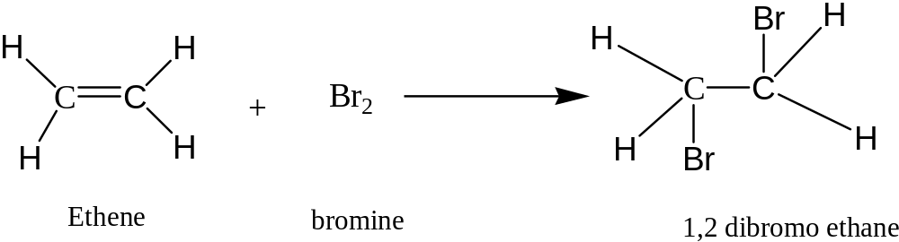

(3) Elimination Reactions: An elimination reaction is a type of organic reaction in which two substituents are removed from a molecule
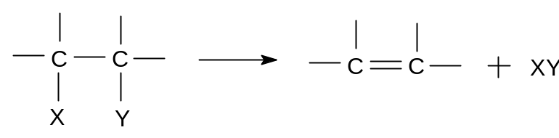

Example: BrCH₂CH₂Br + Zn → CH₂=CH₂ + ZnBr₂

(4) Rearrangement Reactions: A rearrangement reaction is a reactions where the carbon skeleton of a molecule is rearranged to give a structural isomer of the original molecule.
Often a substituent moves from one atom to another atom in the same molecule. In the example below the substituent R moves from carbon atom 1 to carbon atom 2:
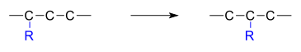
Examples: R-CH (Cl)-CH=CH₂ → R-CH=CH-CH₂ (Cl)

Another example of rearrangement reaction is the formation of Urea from the ammonium cyanate (NH₄CNO).
